**The influence of temperature, rainfall and flood events on salmonella infection patterns in New South Wales, Australia, 1990-2022.**

**Oyelola Adegboye, Tehan, Mohammed, Hassa, Anton, David, Iyke**

**Background**

Infection with Salmonella, known as salmonellosis, is responsible for a significant portion of the global disease burden with an age-standardised mortality rate of 3.0 (i.e. 3 people per 100,000 population, 95% Confidence interval (CI): I 1.4-4.6).8 Salmonella can be transmitted by eating contaminated food (e.g. undercooked meat, eggs, dairy, raw fruits and vegetables), drinking contaminated water, coming into contact with infected person’s faeces or infected animals, e.g. cattle, chickens, rodents, tropical fish and reptiles.1,14 It’s incubation period can vary from 6 hours to 72 hours and they are considered infectious when their stools are positive for Salmonella.1,14 A person can potentially be infectious from days to weeks post acquiring the infection.1 In developed countries such as Australia, it is usually less likely to be fatal, typically manifesting as an acute gastroenteritis9. However, it can spread rapidly and still causes severe illness, particularly in individuals with other medical co-morbidities. Salmonella is spread by eating or drinking contaminated food or water and coming into contact with infected people and animals. In 2015, it was estimated to have 3013 hospitalisations and 13 deaths, resulting in a societal cost of over AUD 100 million7.

There is evidence to suggest foodborne gastroenteritis cases are increasing in Australia2. Several studies have been conducted worldwide showing evidence of Salmonella exhibiting seasonal variation.3, 4, 5, 6 Previous studies have shown a potential relationship with rainfall in Congo3 and temperature associations with Salmonellosis in Malawi4. Literature is also available in the United States of America (USA), demonstrating positive correlations between precipitation and heat with salmonellosis5 and evidence of more rapid replication of Salmonella associated with warming trends in the USA, particularly in the Southern states6. However, little literature exists on the relationship between climate and Salmonellosis in Australia. Hence, this study aims to examine the relationship between the incidence of Salmonella and climate, particularly rainfall, temperature and flood events across different local health districts (LHDs) in Australia’s most populous state: New South Wales (NSW). More specifically, this study examines these relationships based on data available for the years 1991 to 2022 inclusive.

NSW has been fraught with natural disasters including bushfires, cyclones, hailstorms, earthquakes and floods. From 2020-21 it is estimated to have cost the NSW economy 5.1 billion dollars, and these projections are predicted to continue to rise.12 In light of a more rapidly changing climate and the significant health and economic burden of Salmonella, identifying relationships between these variables will be valuable, particularly from the perspective of risk mitigation, surveillance, management and preparedness for possible outbreaks. Although this research will focus on these relationships based on Salmonella incidence in NSW, its outcomes can be extrapolated to other areas of Australia and the world.

**Materials and Method:**

***Data sources and study area***

The data used in this study include climate variables, health-related data and geographic information. This study utilises non-identifiable monthly number of Salmonella cases from the publicly available database NSW Health Notifiable Conditions Information Management System (NCIMS) via the Communicable Diseases Branch and Centre for Epidemiology and Evidence of NSW Health. These notifications were obtained for each local health district (LHD) of NSW. Monthly weather data was derived from the Australian Government’s Bureau of Meteorology website. LHD population data was derived from the NSW government Department of Planning’s website.11 As individual LHD population data was not available for years prior to 2001 from this source or from an alternative reliable source, we used the Department of Planning’s earliest population growth rate (from 2002) to estimate the population backwards for each year up to 1991. This was able to be applied for each LHD separately, similar to the method used by the Department of Planning to project LHD populations into the future.

***Health and Meteorological data***

Publicly available data was extracted from the Australian Bureau of Meteorology website at the weather station level.10The data extracted includes monthly total rainfall (millimetres), mean temperature (degrees Celsius), mean maximum temperature (degrees Celsius) and mean minimum temperature (degrees Celsius) between 1991 and 2022. The climate data from these databases only provide information based on weather station number or latitude and longitude, but not by weather station. Hence, the geographic coordinates of each station were manually matched to their corresponding local health district in NSW using Google Maps. These data were then able to be accordingly matched with the Salmonellosis data.

NSW is one of eight Australian states and territories. Local health districts of NSW can be divided into two main categories: metropolitan and rural/regional. There are a total of six metropolitan LHDs and nine rural/regional LHDs.

Data was able to be obtained for 64 different weather stations for 8 of the 9 rural/regional local health districts in NSW: Far West, Western, Murrumbidgee, Southern, Hunter New England, Northern, Mid North Coast, Illawarra Shoalhaven. Data was not available for the Central Coast. Data was only available for 1 of the 6 metropolitan LHDs of NSW: South Western Sydney. However, it is worth noting that metropolitan NSW comprises only a small proportion of the state of NSW geographically. A LHD map of NSW is included below for geographic visualisation of the different LHDs.

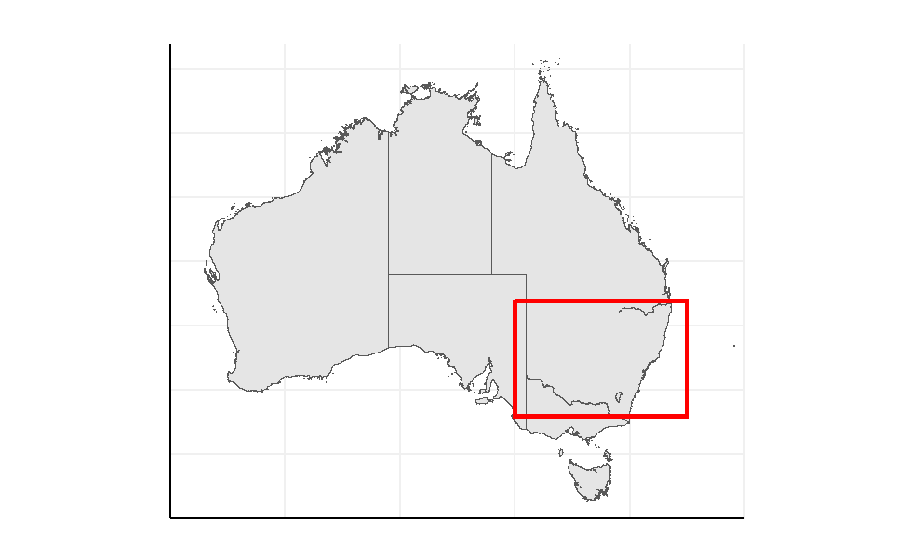

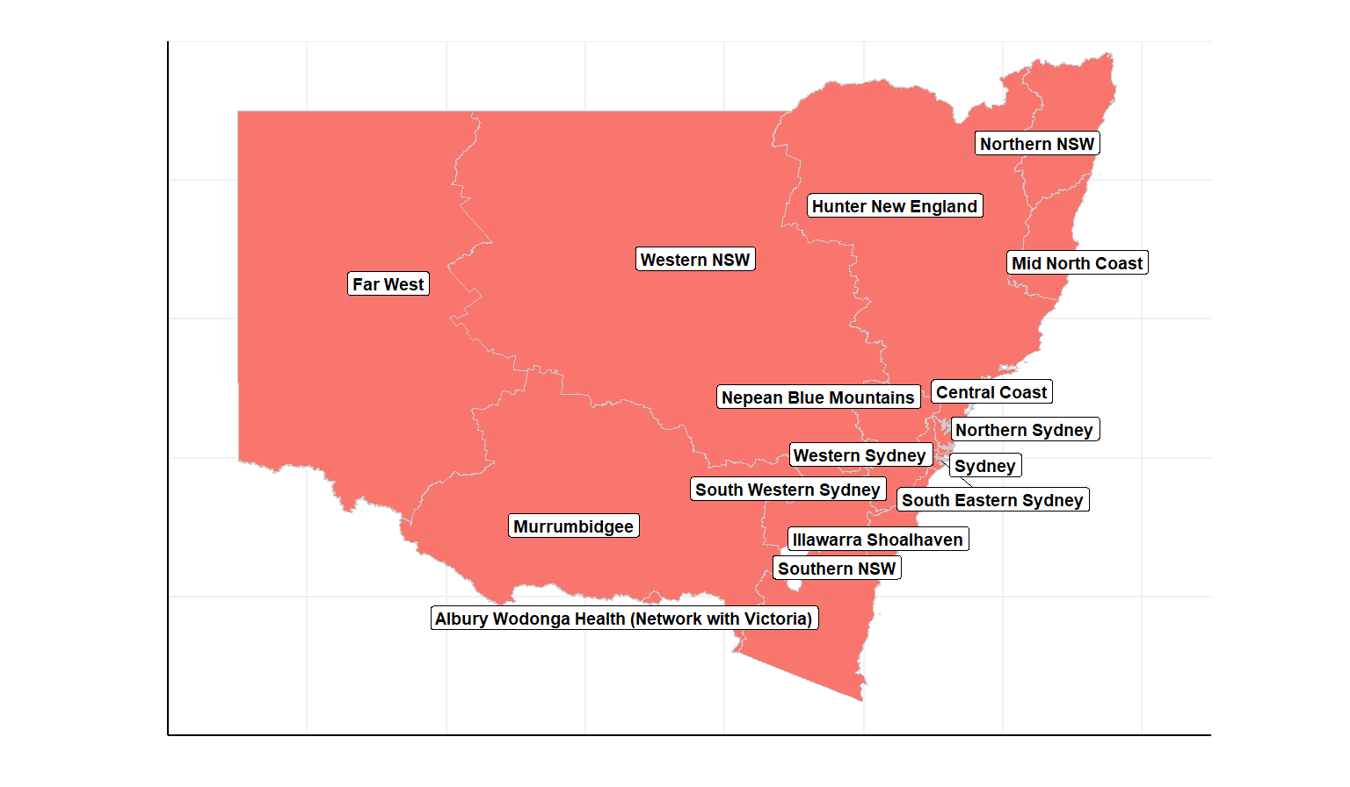

Figure 1. Map of Australia and the study area.

***Statistical analysis***

Statistical analyses were carried out in R version 4.0.1. Preliminary descriptive analyses examined the incidence and prevalence of salmonella and meteorological variables, thereby elucidating the spatial and temporal spread of these phenomena. The data were analysed using distributed lag nonlinear models (DLNM) to investigate the association between health outcomes and climate exposure. DLNM simultaneously model the non-linear effect of environmental exposure and the lag effects.

Geographic Information System (GIS) mapping was used to analyse the disproportionate impacts of environmental exposure on geographic regions. In order to enhance statistical analysis and minimise the effect of these data constraints, we used a method of interpolation known as Bayesian Kriging to estimate the monthly weather data for these missing months and locations. The following is the general formula for Kriging:

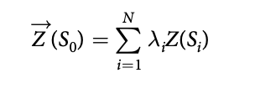

Where  
*Z*(*Si*) is the measured value at the *i* th location  
*λi* is an unknown weight for the measured value at the *i* th location  
*S*0 represents the predicted location  
*N* is the number of measured values  
Here, *λi* depends on the measured points, distance to the prediction location and the spatial relationship among the measured values around the prediction location.

**Ethics**

No specific ethics approval is required for this study. Salmonellosis data were obtained from de-identified notifiable disease data publicly available, whilst the climate data were obtained from the Bureau of Meteorology.

**Data analysis**

We calculatedyearlyincidence ratesper 100,000people of Salmonella cases for each LHD. Pearson rank correlations were used to determine any correlations between salmonella incidence and theclimatevariables. Furthermore, we investigated incidence associatedwith mean temperature, mean maximum temperature, mean minimum temperature andflood wave events (defined as the number of days with water discharge more than the 95thpercentile). Relative risk curves were generated for Salmonellosis associated with mean monthly temperature and with total daily rainfall for each LHD.We also generated basic autocorrelation functions (ACF) and partial ACF for salmonellosis.

Spatial heterogeneity DLNM

**Results**

***Exploratory data analysis***

***scatter plot of 1991 vs (peaked year) with dot size as percentage change***

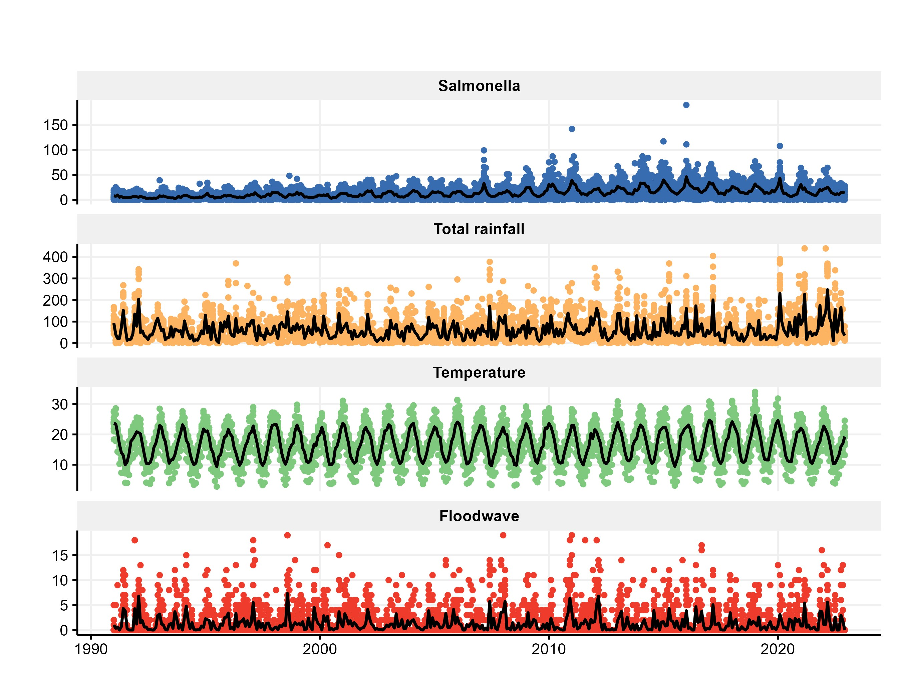

Figure 2. Time series plot of salmonella cases, total rainfall, mean temperature and floodwave over the study period, 1991-2022.

Figure 3. Decomposition of salmonella time series data

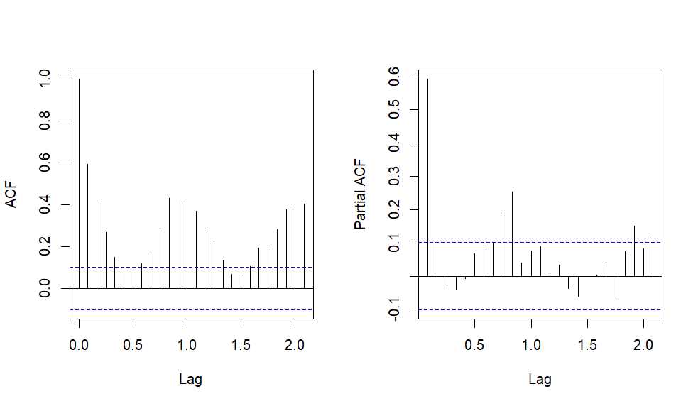Figure 4. ACF/PACF of Salmonella

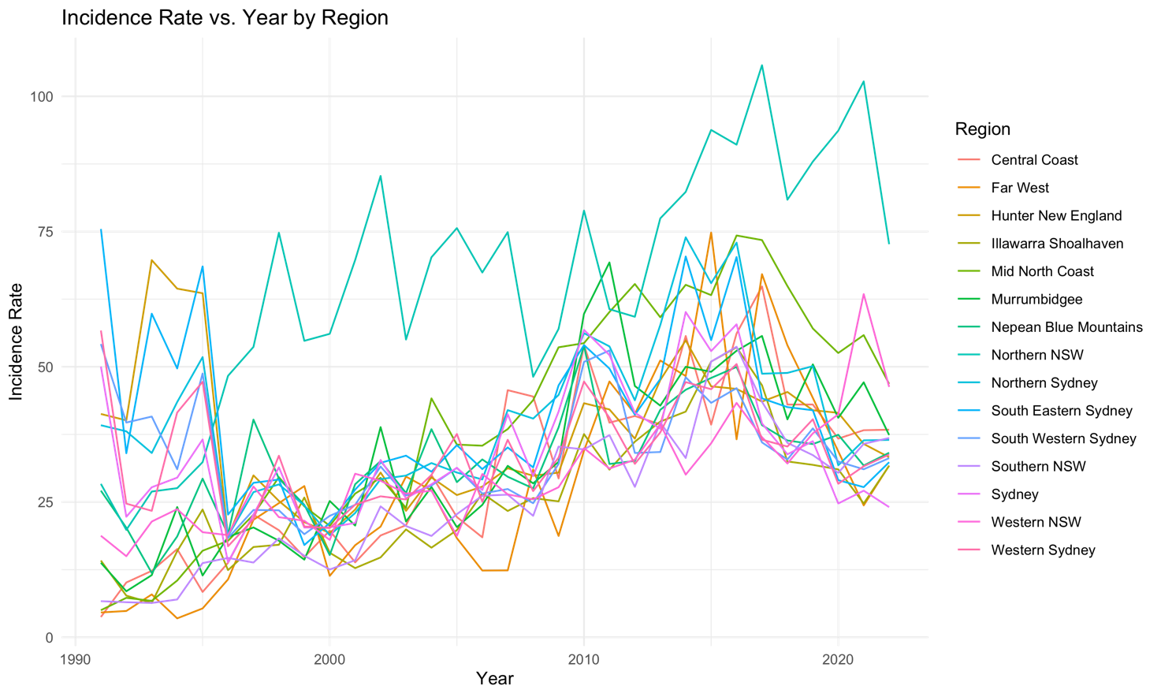

Figure 5

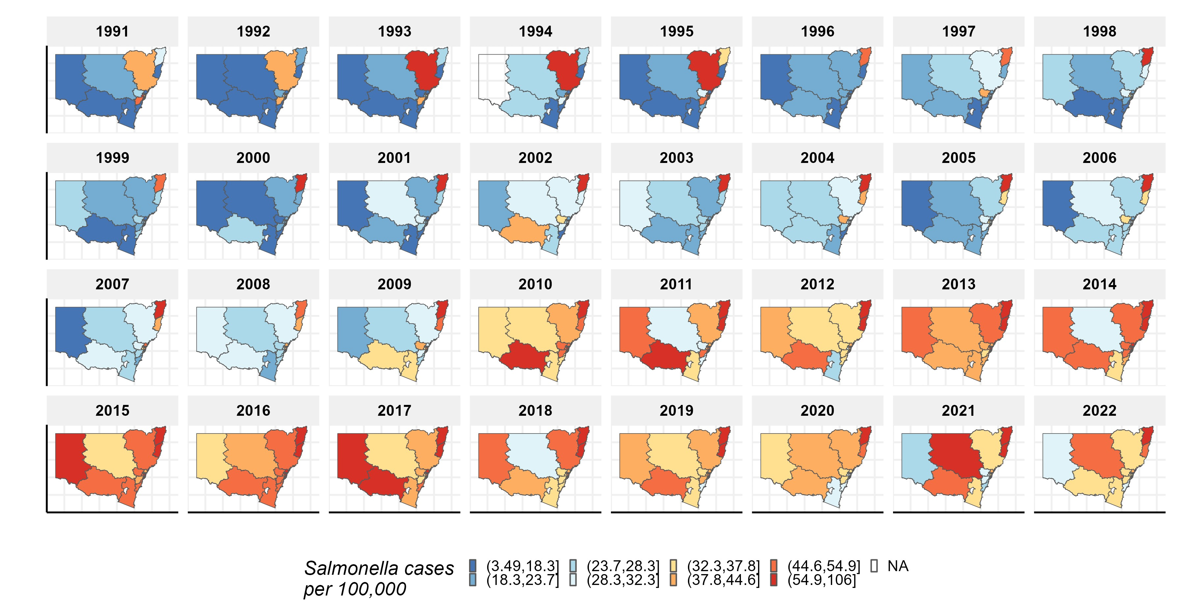

Figure 6. ***Figure 1. Map of NSW LHD showing the geographical distribution of the number of salmonella cases per 100000 over the study period, 1991-2022.***

Figures xxx and Sx show the spatial-temporal pattern of salmonella cases per 100,000 population in New South Wales between 1991 and 2022, revealing geographical heterogeinty and increasing trends over the study period..

Table 1. Summary and  ***inter-correlation analysis of salmonella cases and climatic variables***

|  |  |  |  |  |  |  |  |  |  |  |  |  |  |  |
| --- | --- | --- | --- | --- | --- | --- | --- | --- | --- | --- | --- | --- | --- | --- |
|  |  |  |  | Percentiles | | | |  | Inter-correlation | | | | | |
| **Variable** | **Mean** | **SD** | **Min** | **25th** | **Median** | **75th** | **99th** | **Max** | **2** | **3** | **4** | **5** | **6** | **7** |
| **1. Max. temperature** | 21.51 | 5.34 | 7.15 | 17.5 | 21.46 | 25.1 |  | 40.2 | 0.961 (<.001) | 0.841 (<.001) | 0.047 (<.001) |  | -0.289 (<.001) | 0.242 (<.001) |
| **2. Mean Temperature** | 16.75 | 5.09 | 2.75 | 12.9 | 16.92 | 20.7 |  | 34.1 |  | 0.956 (<.001) | 0.139 (<.001) | 0.065 (<.001) | -0.402 (<.001) | 0.331 (<.001) |
| **3. Min. Temperature** | 12.53 | 5.08 | -0.6 | 8.52 | 12.7 | 16.7 |  | 27.9 |  |  | 0.245 (<.001) | 0.128 (<.001) | -0.465 (<.001) | 0.404 (<.001) |
| **4. Total rainfall (mm)** |  |  |  |  |  |  |  |  |  |  |  | 0.538 (<.001) |  | 0.176 (<.001) |
| **5. Flood Events** | 1.25 | 2.53 | 0 | 0 | 0 | 2 |  | 19 |  |  |  |  |  | 0.113 (<.001) |
| **6. Elevation (m)** |  |  |  |  |  |  |  |  |  |  |  |  |  | -0.207 (<.001) |
| **7. Salmonella Cases** | 13.33 | 13.3 | 0 | 4 | 9 | 18 |  | 190 |  |  |  |  |  |  |

***Meteorological variables-salmonella relationship***

**Discussion**

We analysed 21 years of publicly available Salmonella notification data across different 15 different LHDs of NSW to identify and understand incidence rates and their trends. There were a total of 76794 cases of Salmonella recorded during this time period.

**Figure 1** shows the incidence rate of Salmonella per 100, 000 population across the different health districts. Northern NSW had the highest average incidence rate, whilst Illawarra Shoalhaven had the lowest average incidence rate over the 21 year period. Figures 2a-2e illustrate a time series of all the climatic variables

Cross-correlation analysis of the variables showed that Salmonella incidence was positively correlated with all of the climatic variables. It was most strongly associated with mean monthly minimum temperatures, followed by mean monthly temperature, then mean maximum temperature and then flood events.

Multiple studies have identified a positive relationship between higher temperatures and Salmonellosis, across Asia, Europe and North America ([D'Souza et al., 2004](https://www.sciencedirect.com/science/article/pii/S004896970901050X#bib7), [Kovats et al., 2004](https://www.sciencedirect.com/science/article/pii/S004896970901050X#bib16), [Fleury et al., 2006](https://www.sciencedirect.com/science/article/pii/S004896970901050X#bib8)).

***Consideration of Limitations***

Only confirmed cases of Salmonella were able to entered into the NCIMS public database A confirmed case was defined as one that was able to be confirmed via laboratory isolation, specifically of *Salmonella* species (excluding *S. Typhi*,  *S*.Paratyphi A, *S*. Paratyphi B (with the exception of *S*. Paratyphi B biovar Java) and *S*. Paratyphi C).1 Exclusion of these typhoidal Salmonellas is typical protocol amongst Salmonella notification procedure across Australia and several countries around the world. They are usually listed under a separate category, likely due to their exhibition of different epidemiology, usually associated with overseas travel.15 It is possible that there is under-notification of Salmonella infection, as those with milder symptoms may be less likely to present than those with more severe symptoms, contributing to an underestimation of the calculated incidence rate.

It is important to note that climate variables may not always have a clear, direct impact on the Salmonella incidence. There may be numerous factors that are affected by these climate variables that subsequently result in an indirect delayed impact or ‘lag’ on Salmonella incidence.

Salmonella v temp in HongKong, lag models ~1month

<https://www.sciencedirect.com/science/article/pii/S0160412018309498>

**References**

1. Public Health Laboratory Network. Salmonella genus. Published December 2019. Accessed July 2023. <https://www.health.gov.au/sites/default/files/documents/2022/06/salmonella-laboratory-case-definition.pdf>.

Salmonellosis Control Guideline for Public Health Units

<https://www.health.nsw.gov.au/Infectious/factsheets/Pages/salmonella.aspx#:~:text=Salmonellosis%20(or%20Salmonella)%20is%20a,another%20person%20with%20the%20infection>

2. Ford, L., Glass, K., Veitch, M., Wardell, R., Polkinghorne, B., Dobbins, T., Lal, A., & Kirk, M. D. (2016). Increasing Incidence of Salmonella in Australia, 2000-2013. *PloS one*, *11*(10), e0163989. https://doi.org/10.1371/journal.pone.0163989

<https://www.ncbi.nlm.nih.gov/pmc/articles/PMC5061413/>

3. Tack, B., Vita, D., Phoba, MF. *et al.* Direct association between rainfall and non-typhoidal *Salmonella* bloodstream infections in hospital-admitted children in the Democratic Republic of Congo. *Sci Rep* **11**, 21617 (2021). https://doi.org/10.1038/s41598-021-01030-

4. Thindwa, D., Chipeta, M.G., Henrion, M.Y.R. *et al.* Distinct climate influences on the risk of typhoid compared to invasive non-typhoid *Salmonella* disease in Blantyre, Malawi. *Sci Rep* **9**, 20310 (2019). https://doi.org/10.1038/s41598-019-56688-1

5. Morgado, M.E., Jiang, C., Zambrana, J. *et al.* Climate change, extreme events, and increased risk of salmonellosis: foodborne diseases active surveillance network (FoodNet), 2004-2014. *Environ Health* **20**, 105 (2021). https://doi.org/10.1186/s12940-021-00787-y

6. Akil, L., Ahmad, H. A., & Reddy, R. S. (2014). Effects of climate change on Salmonella infections. *Foodborne pathogens and disease*, *11*(12), 974–980. https://doi.org/10.1089/fpd.2014.1802

7. McLure, A., Shadbolt, C., Desmarchelier, P.M. *et al.* (2022). Source attribution of salmonellosis by time and geography in New South Wales, Australia. *BMC Infect Dis,* 22, 14. <https://doi.org/10.1186/s12879-021-06950-7>

8. GBD 2019 Antimicrobial Resistance Collaborators. Global mortality associated with 33 bacterial pathogens in 2019: a systematic analysis for the Global Burden of Disease Study 2019. *The Lancet, 400,* 2221. <https://doi.org/10.1016/S0140-6736(22)02185-7>

9.Searching for Salmonella. *Australian Family Physician*, 37 (10)https://www.racgp.org.au/getattachment/8860f29c-bb86-499f-a16a-bd748cd6cf59/attachment.aspx

10. Zippenfenig, P. (2023). Open-Meteo.com Weather API. Zenodo. <https://doi.org/10.5281/ZENODO.7970649>

11. <https://www.planning.nsw.gov.au/research-and-demography/population-projections/explore-the-data>

12. natural disaster cost nsw

<https://www.nsw.gov.au/sites/default/files/2022-10/Betterment%20Fund%20vision.pdf>

Climate and salmonella in QLD, lagged effects

13 <https://www.sciencedirect.com/science/article/abs/pii/S004896970901050X?via%3Dihub>

14. WHO salmonella

<https://www.who.int/news-room/fact-sheets/detail/salmonella-(non-typhoidal)#:~:text=of%20the%20world.-,The%20disease,illness%20lasts%202%E2%80%937%20days>.

15. reference from 13, temp/climate on foodborne, lag effect

I.R. Lake, I.A. Gillespie, G. Bentham, G.L. Nichols, C. Lane, G.K. Adak, *et al.*

A re-evaluation of the impact of temperature and climate change on foodborne illness

Epidemiol Infect, 137 (2009), pp. 1538-1547

**Appendix**

***Map of LHDs in NSW:***

*(Top map shows metropolitan LHDs, bottom map shows rural/regional LHDs)*

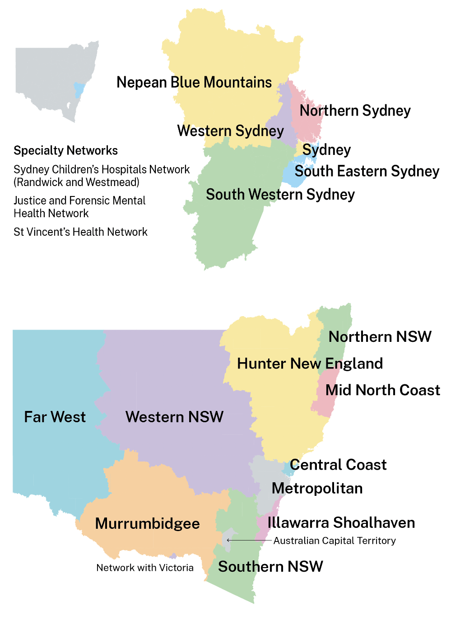

Source: <https://www.health.nsw.gov.au/lhd/Pages/default.aspx>